**KATHRYN MARKEL FINE ARTS PRESENTS AN EXHIBITION OF NEW WORK BY ARTIST GILLIAN THEOBALD IN NEW YORK CITY**

***Gardenwork* features new work by artist Gillian Theobald**

**September 5th - October 12th, 2024**

**NEW YORK, NY –– September 5th, 2024 –– Kathryn Markel Fine Arts** is delighted to announce an upcoming exhibition of works by Gillian Theobald, *Gardenwork*. It will be Theobald’s first solo exhibition with the gallery, and will take place at 529 West 20th Street from September 5th to October 12th. An opening reception will be held on September 5th from 6-8PM.

Gillian Theobald’s artistic practice melds fictive landscapes with materials found in life, transgressing boundaries between imagination and reality. These works–joint in their abstract vernacular–employ distinct methods of creation. Theobald deals in both relief collages and paintings, whose respective practices form a cohesive, poignant body of work. The former emerged as an experiment in form in the 1970s and later became a recurrent component of her oeuvre. Conversely, painting has remained a steady beacon to return to throughout Theobald’s career. Though they draw upon an imagination of natural features, Theobald’s verdant spaces have never existed before. Of her recent work, the artist states, “These paintings are not an abstraction of an actual landscape, but the generation of one that did not previously exist.” Theobald’s practice is indebted to a rich history of spiritual connection to the landscape; one that transcends geographic and chronological boundaries.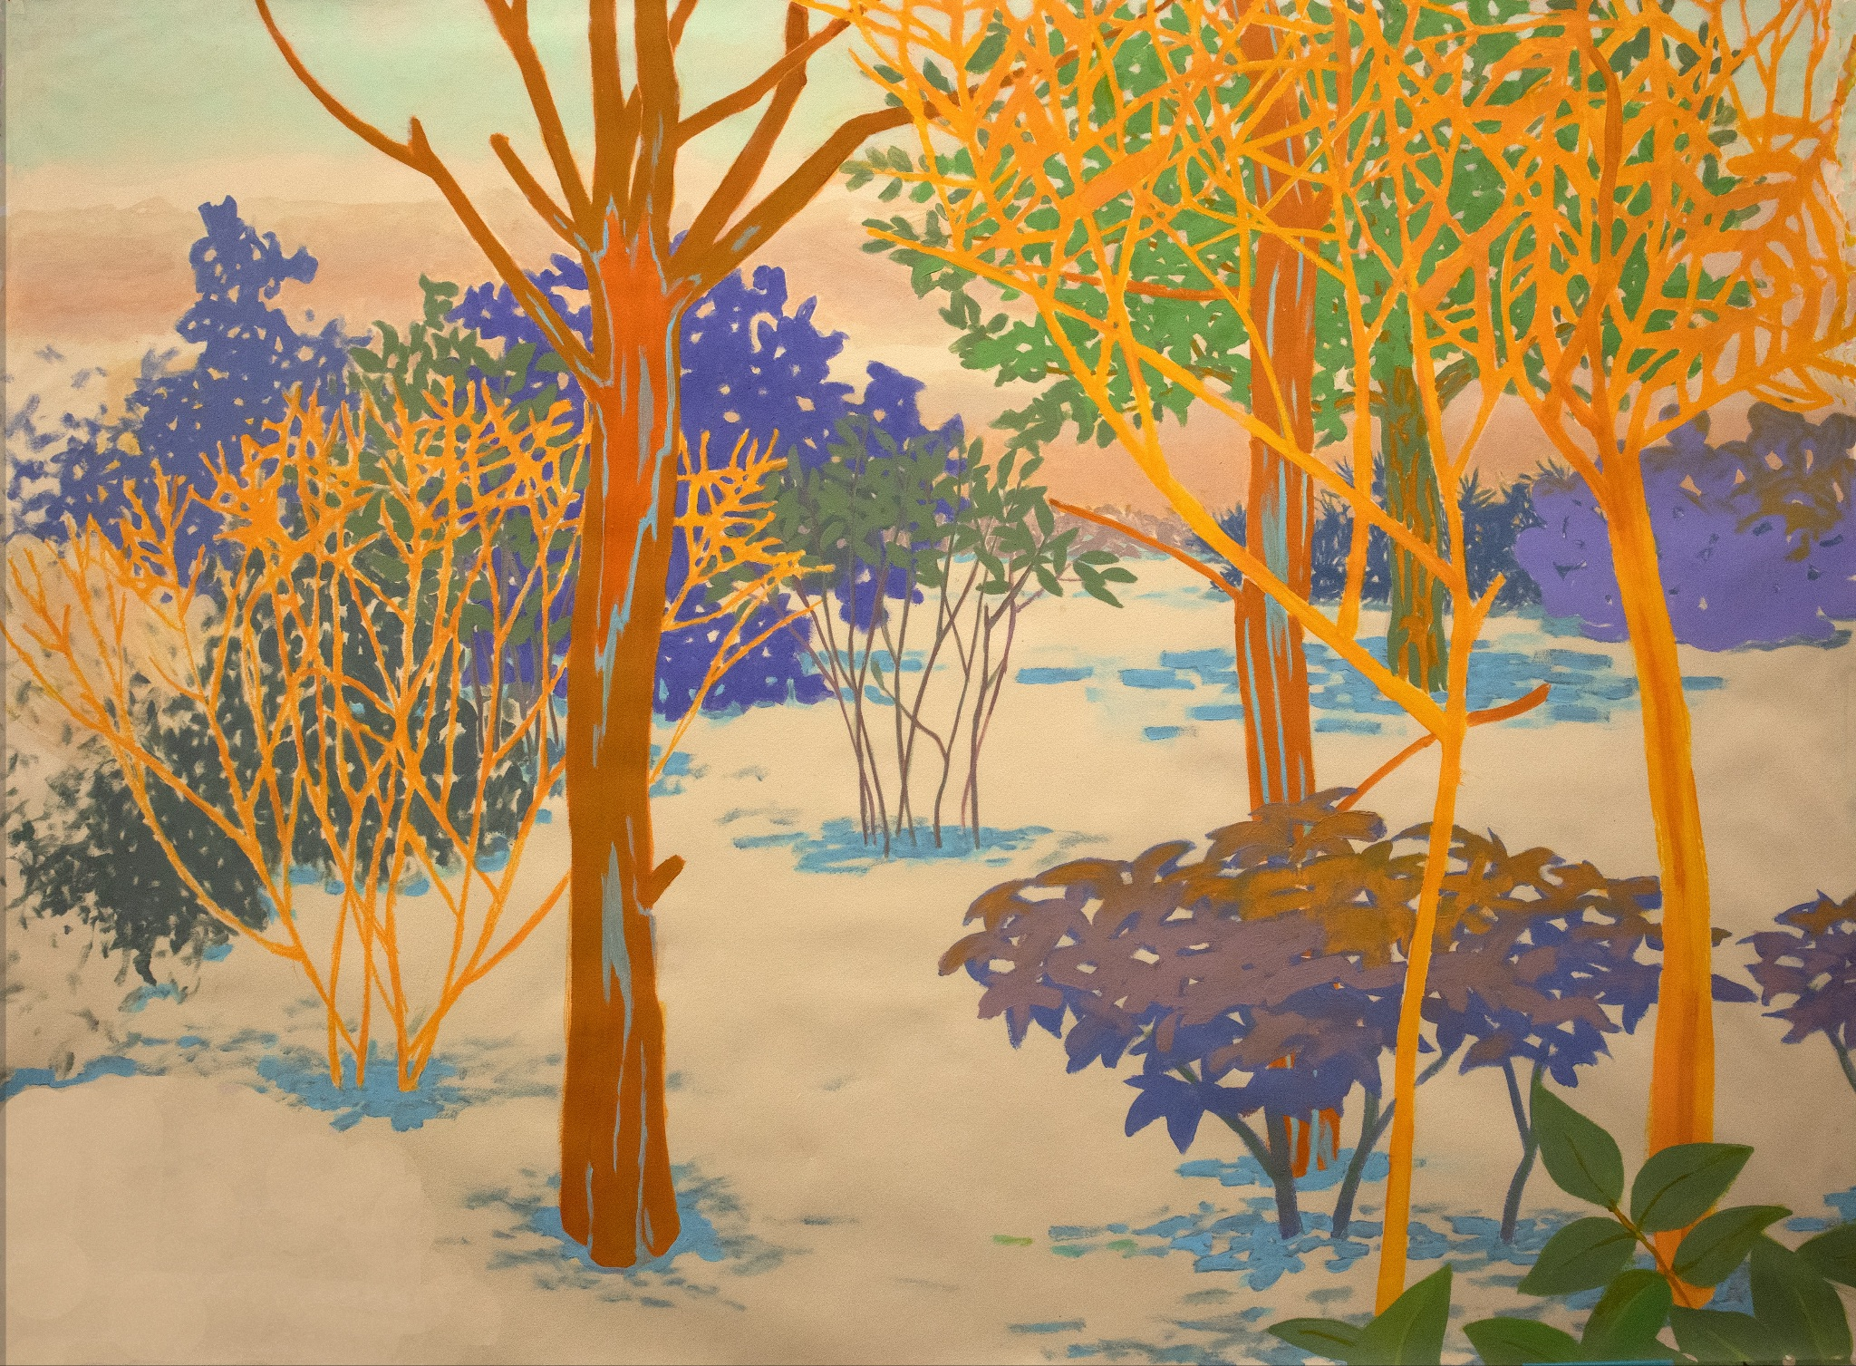

The landscape’s history of subjecthood is fraught: It is bound to social, political, and aesthetic problems and, polemically, often idealized. Theobald’s project aims to depart from the idealized landscape, instead *imagining* the image. These images do not emerge without context: Theobald engages in a practice of interactive dialogue from the initial moment of conception. She states, “As soon as I make a few marks, I have to take those marks into consideration.”

Theobald’s frank titles–*Mimosa*, *Thicket*, *Tulips*…–evoke the basest connection between body and nature, addressing an intuitive feeling rather than a material experience. The artwork is titled for the individual’s sensual encounter with its subject matter. As such, her work possesses a consuming quality: Flecks of warm light emerge from the canvas and envelop the image’s viewer, bringing Theobald’s fictitious landscapes into reality not only by being seen, but by being felt.

Theobald’s formidable career has included solo shows across the nation, including at Cirrus Gallery in Los Angeles, studio e gallery in Seattle, and the Rose Museum at Brandeis in Waltham, MA. She has also participated in group shows internationally, including at No Show Space in London, Paper Art Fair in New York, and the Museum of Fine Arts in Hanoi. Theobald’s bibliography includes reviews by *The Los Angeles Times*, *Artweek*, and *Art in America*.

**IMAGE CAPTION**

Gillian Theobald,  *Fictive Space (Winter) 120*, 2024, acrylic on Okawara paper, 28.5 x 38.5 in.

**MEDIA CONTACT**

Emily Vescio

[emily@markelfinearts.com](mailto:emily@markelfinearts.com)

**ABOUT KATHRYN MARKEL FINE ART**

Established in 1975 with the belief that significant contemporary art can be beautiful as well as visually and intellectually rigorous, Kathryn Markel Fine Art is committed to the experience of discovery and collecting at the highest level. Committed to serving a deep network of collectors and institutions, Kathryn Markel Fine art showcases a diverse array of primary market artists, unified by excellence in their craft, compelling intellectual framework, and a love of the art-making process. <https://www.markelfinearts.com/>

**20th Street**

529 W 20th St. 6W

New York, NY 10011

**10th Avenue**

179 10th Avenue

New York, NY 10011