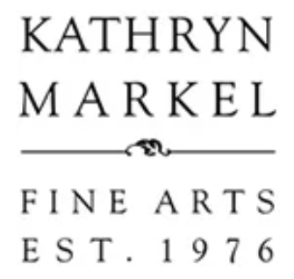
KATHRYN MARKEL FINE ART PRESENTS EXHIBITION OF NEW WORKS
BY ARTIST STEVEN BARIS

Toppling Features 6 Works From Three Series from the Acclaimed Painter
On View in New York City May 13 – June 19, 2021
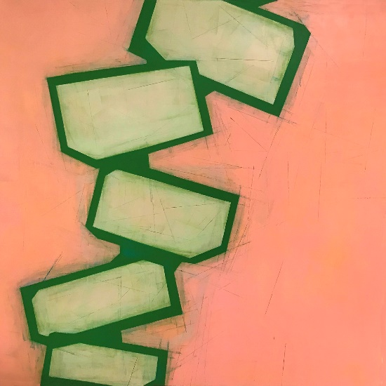 | 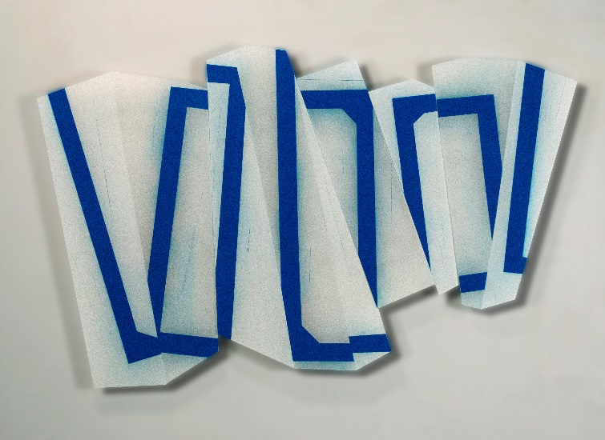
NEW YORK, NY, May 13, 2021 | Kathryn Markel Fine Arts is pleased to present Toppling, an exhibition of six new paintings by artist Steven Baris. Anchored by a new series Toppling created during the pandemic, the works explore discontinuity and disequilibrium of the upheaval and disruption of 2020 and beyond. Toppling will be on view in Chelsea May 13 – June 19, 2021.
“A common thread connecting the separate but related groups of paintings is an obsession with the spatial and temporal disjunctions that we are experiencing in our rapidly changing world,” states Baris. “To that end, I deploy what I describe as diagrammatic metaphors that visualize ongoing processes of movement and transformation.”
Toppling
The Toppling series was entirely created during the pandemic and offers a visual analog to the profound disequilibrium we are experiencing, both privately and institutionally. Baris likens each artwork to a freeze-frame of a film sequence at the precise inflection point when a building, a body, a psyche, or a society begins to succumb to gravity.
Dys/Junctures
The Dys/Junctures series extends Baris’ long running fascination with discontinuities, disruptions, and detours. Deploying diagrammatic metaphors that entail rudimentary framing and bracket motifs, these hybrid paintings/constructions are composed of multiple and decidedly skewed and misaligned panels made of MDF board, plexiglass or a combination of both.

Jump Cut
The Jump Cut series is a cinematic term for a specific kind of failure (purposeful or not) to convey an illusion of continuous time and space. This occurs in the editing when contiguous clips of the same subject are sequenced from camera positions that vary only slightly, causing a disruption of the viewer’s experience of seamless cinematic space and time. For Baris, the jump cut offers the perfect analog to the kinds of spatial and temporal disjunctions we often experience in our hyper networked and kinetic world. The representation of space and time in Baris’ work is not cinematic but rather diagrammatic: a geometric syntax of nested and overlapping frames. Baris’ interest lies in how these arrays of conflicting spatial cues and disrupted sequences conjure a sense of space and time that is highly elastic and ambiguous.
IMAGE CAPTIONS (L to R):
Steven Baris, Toppling E13, 2021, oil on canvas, 59 x 59 in., courtesy of Kathryn Markel Fine Arts
Steven Baris, Dys/Junctures K8, 2021, oil and acrylic on five plexiglass panels, 27 x 41.5 inches, courtesy of Kathryn Markel Fine Arts

MEDIA CONTACT
Sarah Brown McLeod
sarah@sarahbrownmcleod.com

ABOUT KATHRYN MARKEL FINE ART
Established in 1975 with the belief that significant contemporary art can be beautiful as well as visually and intellectually rigorous, Kathryn Markel Fine Art is committed to the experience of discovery and collecting at the highest level. Committed to serving a deep network of collectors and institutions, Kathryn Markel Fine art showcases a diverse array of primary market artists, unified by excellence in their craft, compelling intellectual framework, and a love of the art-making process.
https://www.markelfinearts.com/

New York City
529 W 20th St.
New York, NY 10011

Bridgehampton
2428 Montauk Hwy
Bridgehampton, NY 11032

